JSON DATA FORMAT AND COMMUNICATION FLOW

- Revision Number:
Rev. 2.0
- Date of Creation or Update:
17/1/2025
- Prepared By:
Muhammad Sabahat Akhter

Reviewed By:

JSON Data Format Overview
The following is a structured JSON message generated by the ESP8266 d1 mini. This format is designed to transmit data about a battery management system and additional features to the Cloud server via websockets. The key fields provide real-time telemetry of various parameters:

Sample JSON Structure:
{
"Slot_ID": 1,
"BRN_ID": "XXYY", // Battery registration number
"Voltage": 162.5, // Battery voltage in volts
"Current": 9.2, // Battery current in amperes
"SoC": 85, // State of Charge in percentage
"Ext_Temperature": 30.0, // External temperature in Celsius
"Bat_Temperature": 35.5, // Battery temperature in Celsius
"Flame_status": 0, // 0 = No flame, 1 = Flame detected
"Door_status": 1, // 0 = Door closed, 1 = Door open
"Charging_status": 1 // 0 = Not charging, 1 = Charging
}

Dynamic Field Inclusion
The JSON structure is flexible and fields may increase or decrease based on the system features enabled. For example:
- Added Features:
  - Humidity, pressure, or GPS data.
  - Additional battery-related fields such as cycles or capacity.
- Removed Features:
  - If a feature (e.g., flame detection) is not included in the system, its corresponding field may be omitted.

ESP8266 to STM32 Communication

Serial Communication Setup
- The master ESP8266 module communicates with the STM32 using its available TX and RX pins via UART (Universal Asynchronous Receiver-Transmitter).
- The goal is to receive all the parameters using serial communication from stm32 to esp8266 for further processing data to cloud server.
- The STM32 will receive the JSON message string through this UART interface for further processing.

Hardware Requirements:
- Connections:
  - ESP8266 TX -> STM32 RX
  - ESP8266 RX -> STM32 TX
  - Common GND between ESP8266 and STM32.
- Baud Rate:
  - Set an appropriate baud rate (e.g., 9600, 115200) for reliable communication.
- Voltage Levels:
  - Ensure the voltage levels are compatible (3.3V logic). Use a level shifter if the STM32 operates at a higher voltage (e.g., 5V).

Software Implementation:
- STM32:
  - Configure Uart communication to receive and transmit response with Esp8266
  - Convert the data into a JSON string and transmit it over the UART using Serial.print() or similar commands to esp8266.
  - Example:
  - String message ="Slot_ID: " + String(1) +
  - "BRN_ID: " + String(response.brnID)+
  - "Voltage: " + String(response.voltage) +
  - "Current: " + String(response.current) +
  - "SoC: " + String(response.soc) +
  - "Ext_Temperature " + String(response.ext_Temp) +
  - "Bat_Temperature:"+ String(response.temperature) +
  - "Flame_status: " + String(response.fireDetected) +
  - "Door_status: " + String(response.lockStatus) +
  - "Charging_status:"+ String(response.charging_status);
Serial.println(message);
- ESP8266:
  - Configure UART to receive JSON data.
  - Save the received parameters and transmit to our cloud server for further processing.

CHARGING STATION COMMUNICATION FLOW
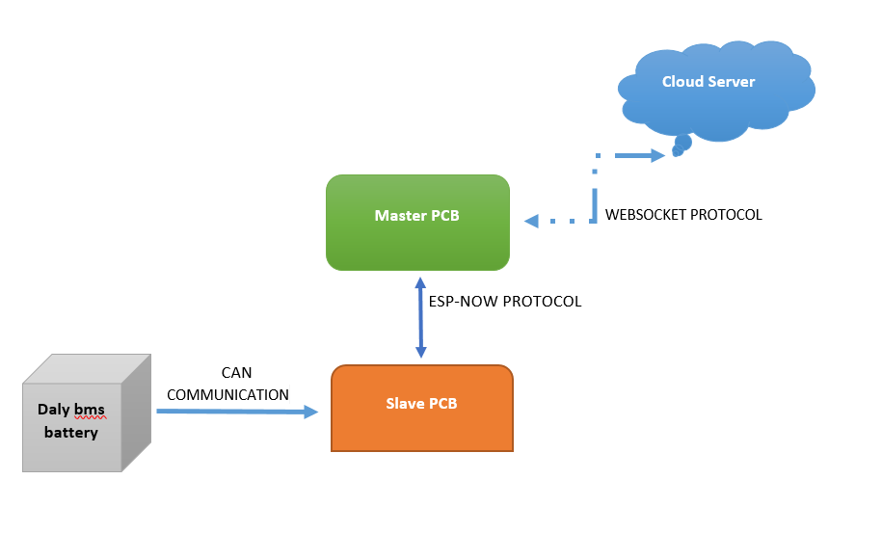
This diagram represents a communication and data flow system involving a Daly BMS battery, Master PCB, Slave PCB, and a cloud server. Here's a brief explanation of each component and the protocols used:

1. Daly BMS Battery
- Description: The battery management system (BMS) monitors and manages the battery's health, voltage, current, and other parameters.
- Communication:
  - The Slave PCB communicates with the Daly BMS battery via CAN Communication Protocol.
  - CAN (Controller Area Network) is for real-time data exchange in battery systems.

2. Slave PCB
- Role:
  - Acts as a bridge between the Daly BMS battery and the Master PCB.
  - Collects battery data such as voltage, state of charge (SoC), temperature, etc., through CAN communication.
  - Collects and control sensors data.
- Communication with Master PCB:
  - Uses the ESP-NOW Protocol to wirelessly send the collected data to the Master PCB.
  - ESP-NOW: A lightweight and fast wireless communication protocol provided by ESP8266/ESP32, ideal for short-range communication with minimal latency.

3. Master PCB
- Role:
  - Receives data from the Slave PCB.
  - Processes and relays data to a cloud-based server for remote monitoring and control.
- Communication with Cloud Server:
  - Uses the WebSocket Protocol for communication.
  - WebSocket: Enables full-duplex communication, making it efficient for real-time updates and control.

4. Cloud Server
- Role:
  - Acts as a centralized system to monitor all connected devices.
  - Provides a web or mobile interface for users to view battery and system data in real time.
  - Sends control commands (e.g., to open slot door) back to the Master PCB.

Protocols Used
- CAN Communication: For reliable wired communication between the BMS and the Slave PCB.
- ESP-NOW: For wireless, fast, and lightweight data transfer between the Slave PCB and Master PCB.
- WebSocket Protocol: For real-time, bidirectional communication between the Master PCB and the cloud server.

Purpose of the System
- Real-time monitoring: Battery parameters are monitored via the cloud.
- Wireless Communication: Simplifies the system by using ESP-NOW for short-range and WebSocket for long-range communication.
- Remote control: Allows users to control and monitor data from anywhere through the cloud.

